Service of Thanksgiving and Camp Fire Gathering
honoring 60 years of Camp at the Eastward
Date: Saturday, October 30,
Time: 11:00--2:00 pm
Place: Camp at the Eastward, 68 Sawyers Mills Rd, Starks, ME 04911
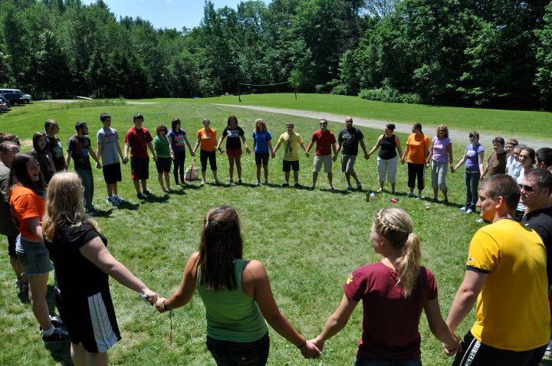
Friends, campers, camp staff, supporters - please join us as we give thanks for the many years of fellowship at the Camp.
There will be a service of thanksgiving at the chapel in the woods, led by Rev. Scott Planting, followed by a potluck lunch, and a gathering round the camp fire when stories and memories can be shared and spirits and friendships renewed.
Please bring a potluck contribution, a camp chair or blanket to sit on, and plenty of memories/songs/photographs to share. Masking is encouraged for all as physical distancing will be difficult to achieve at times.
For optimal planning it would be good to have an idea of the numbers coming so it would be helpful, though not essential, to let Jean Roesner know if you plan to come or send her a message that could be read out at the gathering: jean.m.roesner@gmail.com

