Service of Worship
Leeds Community Church
May 24, 2020 Rev. Steve Allman, pastor of LCC

* You may stand.
PRELUDE
BELLS
WELCOME
ENTERING SACRED SPACE
“Every moment and every event of every man's life on earth plants something in his soul.” -Thomas Merton

*OPENING SENTENCES (adapted from Psalm 68)
Let the righteous be joyful; let them exult before God; let them be jubilant with joy. Sing to God, sing praises to his name; lift up a song to him who rides upon the clouds—his name is the Lord— be exultant before him. Father of orphans and protector of widows is God in his holy habitation. God gives the desolate a home to live in; he leads out the prisoners to prosperity, but the rebellious live in a parched land. Ascribe power to God, whose majesty is over Israel; and whose power is in the skies. Awesome is God in his sanctuary, the God of Israel; he gives power and strength to his people. Blessed be God!

MUSIC

*PRAYER OF INVOCATION
O God, your Son, Jesus, prayed for his disciples and sent them into the world to proclaim the coming of your kingdom. By your Holy Spirit hold the church in unity, and keep it faithful to your Word, so that, breaking bread together, we may be one with Christ in faith, love, and service, now and forever. Amen.

*PRAYER OF CONFESSION
﻿﻿﻿Loving God, we confess that we do not always bring honor and glory to your name. We are rebellious and weak; we flee before your goodness. Forgive, restore, and strengthen us by the ﻿grace and mercy of Christ, that we may rise up again in peace to love and serve your world. Amen.

Time for silent confession

*ASSURANCE OF PARDON
﻿﻿Hear the good news! Hope does not disappoint us, for God’s love has been poured into our hearts through the Holy Spirit given to us in baptism. Be thankful and live as people who have been raised to new life. In Jesus Christ we are forgiven. Thanks be to God. Amen.

ANNOUNCEMENTS

HEARING GOD’S WORD
﻿Loving God, fountain of every blessing, open us to your life-giving word and fill us with your Holy Spirit so that living water may flow through our hearts: a spring of hope for a thirsty world; through Jesus Christ our Lord. Amen.

Scripture Readings: Acts 1:6-14, 1 Peter 4:12-14, 5:6-11

SERMON

MUSIC

CONCERNS AND CELEBRATIONS

PRAYERS OF THE PEOPLE, PRAYER OF DEDICATION

OFFERING: Please visit Leeds Community Church on PayPal or mail a check to us at PO Box 228, Leeds, ME 04623 if you want to donate.

MUSIC

*BENEDICTION: ﻿May God, who creates, redeems, and sustains, keep you steadfast in faith, buoyant in hope, and abounding in love. And the blessing of God, Father, Son, and Holy Spirit, be among you and remain with you always. Amen.

MAY THE PEACE OF CHRIST BE WITH YOUALL.

Calendar of Events: (see insert)

Portions of this worship service were taken from the following sources:
Long, Kimberly Brackett, ed. Feasting on the Word Worship Companion: Liturgies for Year A, Volume 1: Advent through Pentecost. Louisville: Westminster John Knox Press, 2013. Kindle Edition.
Office of Theology and Worship. Book of Common Worship. Louisville: Westminster John Knox Press, 2018.

Biography:
Rev. Allman is happy to be serving in Leeds. He grew up in eastern Pennsylvania and spent time in sales and teaching before attending Pittsburgh Theological Seminary. Before coming to Maine, he served churches in West Virginia, New York, and South Dakota. He’s currently pursuing a Doctor of Ministry Degree at Pittsburgh Theological Seminary. You can reach him at (207) 240-2958 or revallman@gmail.com.

ELDERS: Brenda Lake Bill Flewelling
Larry Jewett Barbara Grant

DEACONS: Patricia Leblond Irene Woodward
Dale Holt Donna Holt
Bill Grant Sandy Nutting
Sue Jewett Joyce Pratt

The Sacrament of Holy Communion is shared on the first Sunday of each month.
The first Sunday of each month we collect bottles to benefit the accessibility fund.

DEACONS – 1ST Monday of every month, 6:30 p.m.
SESSION – next meeting in April
WOMEN’S ASSOC. – 2nd Wednesday of every month

SUNDAY SCHOOL – 9am on Sunday

Website: www.leedscommunitychurch.org Like us on Facebook
Email: leedscommunitychurch.me@gmail.com phone: (207) 524-5444

Clerk of Session: Carole Barker
Chair of Deacons: Karen Fish
Church Treasurer: Barbara Grant
Organist/Choir Director: Eileen Coyne
Women’s Association: Lois Hathaway
Leeds Community Church

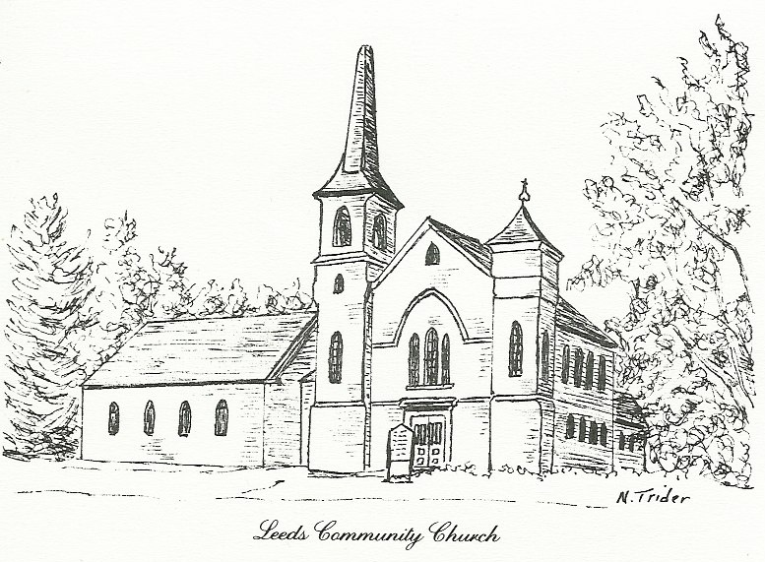
We are a Christian church that is committed to carrying out the mission of Christ. We, therefore, are socially active. Our church is open to all people, regardless of background or any other status. “Just as you did it to one of the least of these who are members of my family” is never far from thought. We pray that every person will feel acceptance, the love of Christ, the joy of the Holy Spirit, and the wonder of God’s grace.

