Service of Worship
Leeds Community Church
December 8, 2019 Rev. Steve Allman, pastor of LCC

* You may stand.
PRELUDE
BELLS
WELCOME
ENTERING SACRED SPACE
“Every moment and every event of every man's life on earth plants something in his soul.” -Thomas Merton

*CALL TO WORSHIP (based on Romans 15 & Psalm 72)
May the God who gives endurance and encouragement give you the same attitude of mind toward each other that Christ Jesus had.
May the God of hope fill you with all joy and peace as you trust in him.
May his name endure forever and his fame continue as long as the sun.
May all nations be blessed in him and pronounce him happy.
Blessed be the Lord, the God of Israel, who alone does wondrous things.
Blessed be his glorious name forever; may his glory fill the whole earth.

*HYMN #423 “Jesus Shall Reign Where’er the Sun”

*PRAYER OF INVOCATION
O Root of Jesse, stir up your power within us, so that in this time we may await with abundant expectation the fulfillment of your eternal presence in creation, for you live and reign among us, Maker, Savior, and Giver of Life, one God, now and forever. Amen.

CANDLE-LIGHTING (congregational response: God of promise, God of peace, into our darkness come. Amen.)

*PRAYER OF CONFESSION
Gracious and welcoming God, have mercy on your people. We confess that we do not believe in your incarnation. We do not heed your word each day in all that we say and do. We do not see our neighbors, families, and friends as beloved children whom you have made. In your mercy forgive us, for we repent of our ways and look to your power to heal us and raise us up, so that, at the last, you will gather us to you and give us peace. Amen.

*ASSURANCE OF PARDON
The reign of God has come near and the repentant will be judged with righteousness. Be filled with hope, believing in the power of the risen Christ to bring you to new life. Believe the good news of the gospel:
In Jesus Christ we are forgiven. Thanks be to God. Amen.

*GLORIA PATRI (579)

TIME WITH THE CHILDREN
ANNOUNCEMENTS

PREPARE TO HEAR GOD’S WORD
SCRIPTURE READINGS Isaiah 11:1-10 (pp. 640-641 OT), Matthew 3:1-12 (pp. 2-3 NT)

SERMON “Penitence”

*HYMN #14 “Savior of the Nations, Come”

CONCERNS AND CELEBRATIONS
PRAYERS OF THE PEOPLE

OFFERING
*DOXOLOGY (592)
*PRAYER OF DEDICATION

*HYMN #27 “Gentle Mary Laid Her Child”

*BENEDICTION
*RESPONSE #438 “Blest Be the Tie That Binds” verse 1
*GREET ONE ANOTHER WITH THE PEACE OF CHRIST
*POSTLUDE
Calendar of Events: (see insert)

Biography:
Rev. Allman is happy to be serving in Leeds. He grew up in eastern Pennsylvania and spent time in sales and teaching before attending Pittsburgh Theological Seminary. Before coming to Maine, he served churches in West Virginia, New York, and South Dakota. He’s currently pursuing a Doctor of Ministry Degree at Pittsburgh Theological Seminary. You can reach him at (207) 240-2958 or revallman@gmail.com.

ELDERS: Jane Wheeler Bill Flewelling
Larry Jewett Barbara Grant

DEACONS: Karen Fish Irene Woodward
Dale Holt Donna Holt
Sandy Nutting
Sue Jewett Joyce Pratt

The Sacrament of Holy Communion is shared on the first Sunday of each month.
The first Sunday of each month we collect bottles to benefit the accessibility fund.

DEACONS – 1ST Monday, 6:30 p.m.
SESSION – Friday, 11/15/19, 2:00 p.m.
WOMEN’S ASSOC. – 2nd Wednesday

SUNDAY SCHOOL – 9am on Sunday

Website: www.leedscommunitychurch.org Like us on Facebook
Email: leedscommunitychurch.me@gmail.com phone: (207) 524-5444

Clerk of Session: Carole Barker
Chair of Deacons: Karen Fish
Church Treasurer: Barbara Grant
Organist/Choir Director: Eileen Coyne
Women’s Association: Lois Hathaway

Leeds Community Church

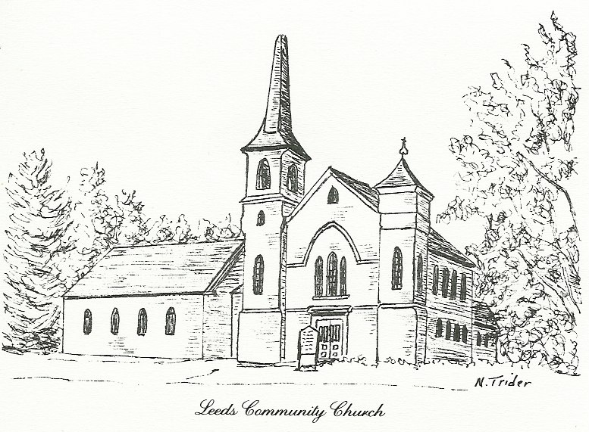
We are a Christian church that is committed to carrying out the mission of Christ. We, therefore, are socially active. Our church is open to all people, regardless of background or any other status. “Just as you did it to one of the least of these who are members of my family” is never far from thought. We pray that every person will feel acceptance, the love of Christ, the joy of the Holy Spirit, and the wonder of God’s grace.

